## Installation Guide

### System requirements

* Operation system: Windows 7 (32 or 64 bit) or later
* Memory: 2G RAM or more
* Browser: Firefox v25 or later
* IIS feature is turned on

### Installation

#### Deploy Database

* Run script file “~/FootballPitchesBooking/Database/FootballPitchesBooking.sql” in SQL Server Management Studio.

#### Deploy Application

* Open “Internet information Services (IIS) Manager”.
* Right click on “Sites” folder in left content, select “Add Web Site”.

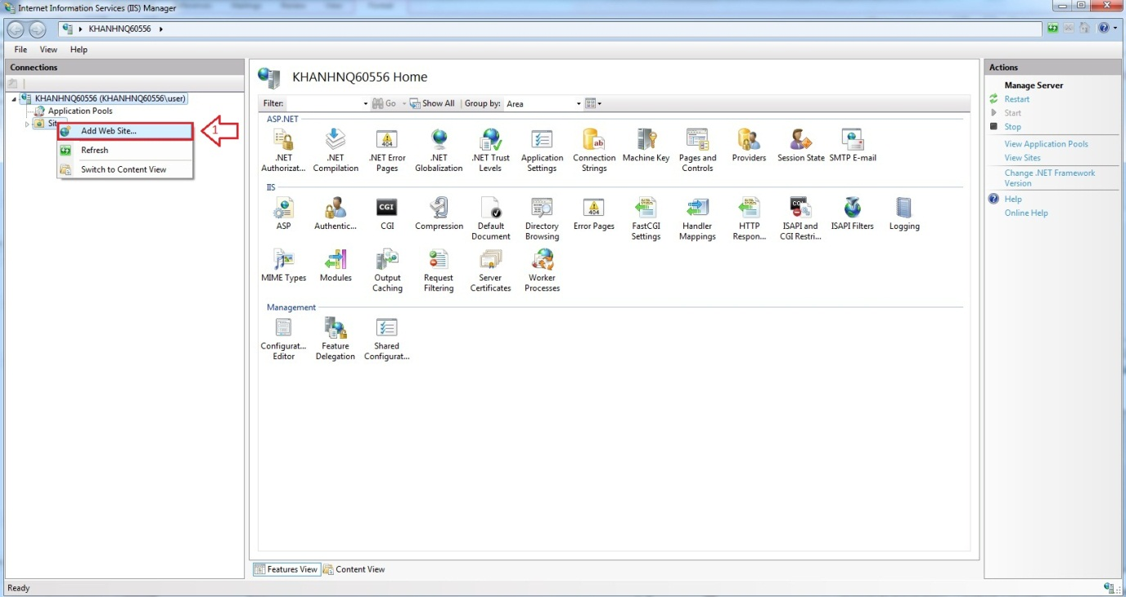

Figure

* Enter “Site Name”.
* Click on “Select” button to select Application pool.

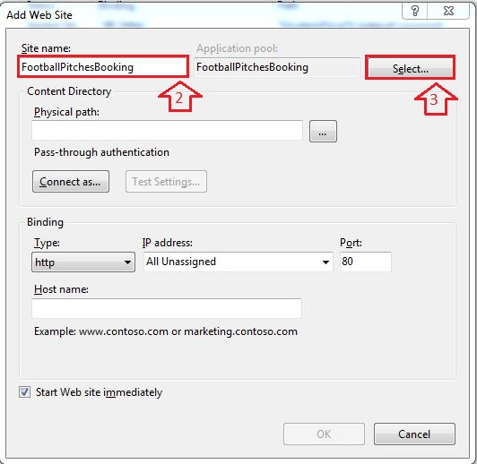

* Select “ASP.NET v4.0”.

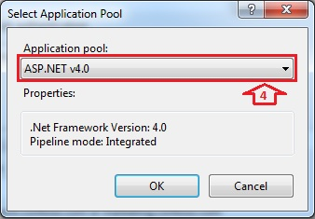

* Browse physical path: “~/FootballPitchesBooking/ FootballPitchesBooking”.

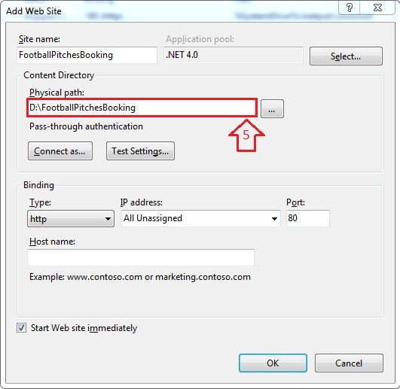

* Open “~/FootballPitchesBooking / FootballPitchesBookingProject/Web.config” file by Notepad.

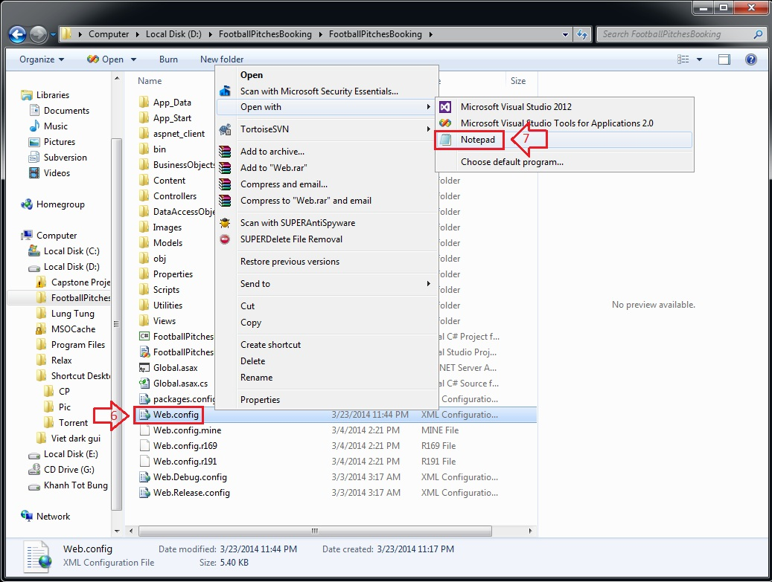

* Find “connectionStrings” tag, change “Server Name”, “User ID” and “Password” in its connection string depend on your computer.

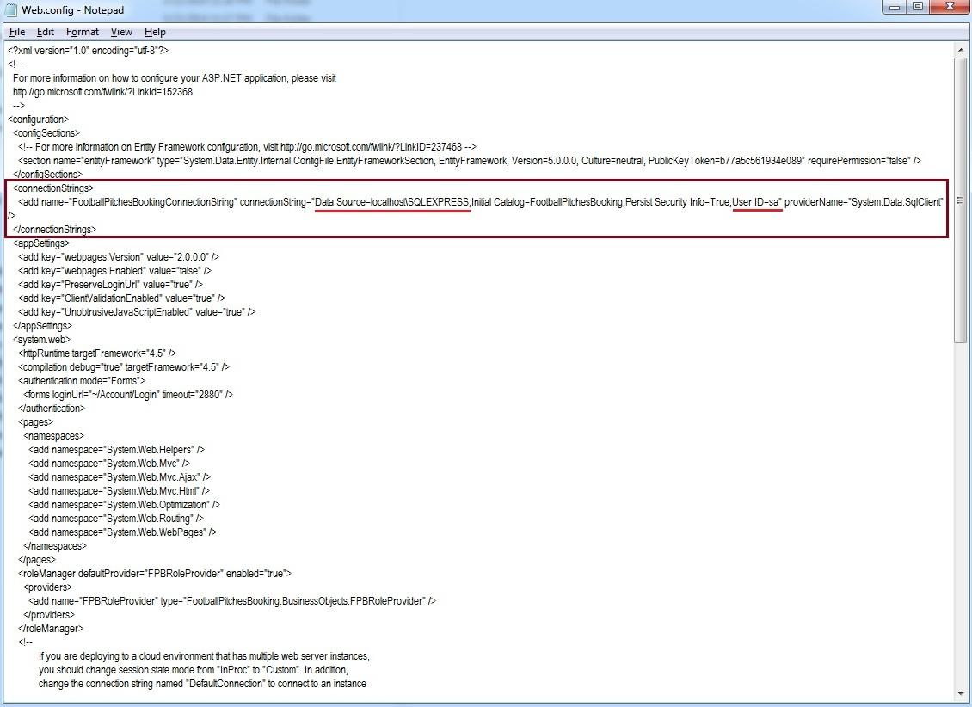

* Right click on new site name (FootballPitchesBooking) in left content -> Manage Web Site -> Browse to view the website.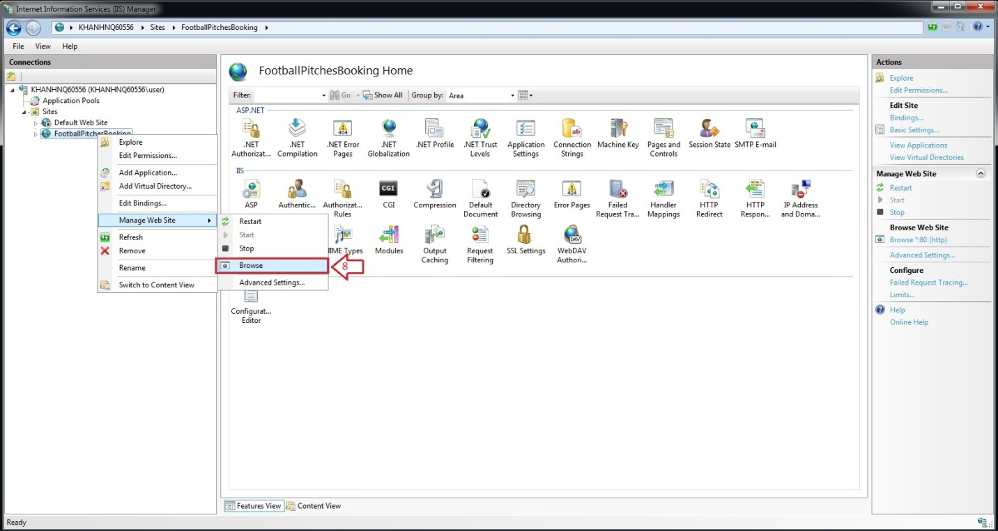
* The website is deployed.

